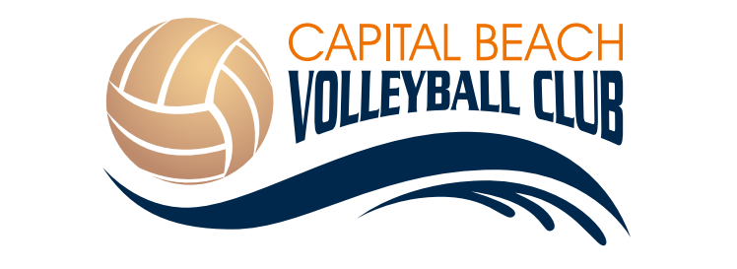

Elite 2017
Female and Male - Born in 1999-2003
Competition
Teams must compete in at least 3 tournaments to qualify for Atlantics. You must participate at Atlantics to participate at Nationals. Registration costs will be paid by teams to give flexibility in scheduling summer events. Coaches will be present at all tournaments, except July 1-2 in Halifax. Build your own schedule.
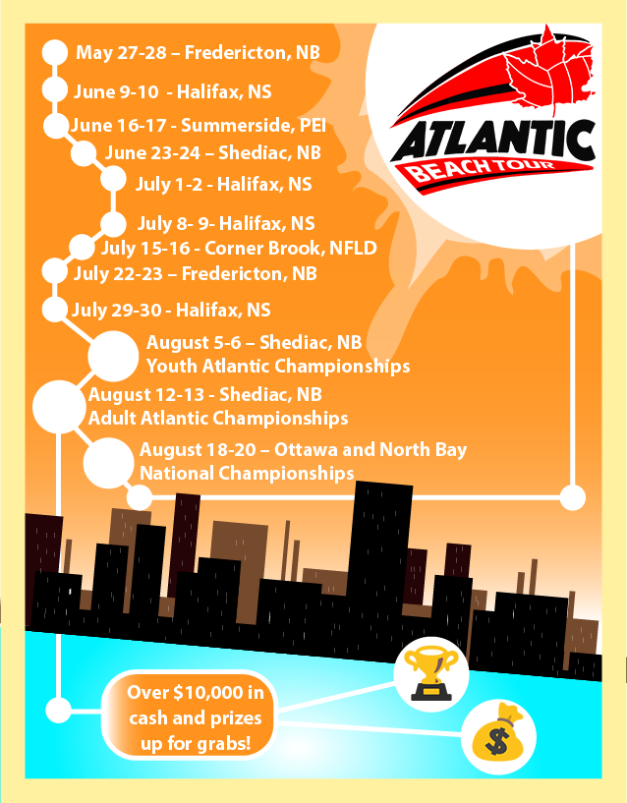
.

Training Cost: $300

- 14u/16u Girls Monday night participation in the CBVC League at Carman Creek/Bliss Carmen from 6-9pm, Starting June 4th – August 14th.
- 18u Girls Tuesday night participation in the Fredericton Women’s Beach Volleyball League at Willie O’Ree/Rugby Club from 6-9pm. (Start date TBD)
- 14u/16u Boys Tuesday night participation in the CBVC boys league at Bliss Carmen from 5-9pm, starting June 6th to August 15th.
- 18u Boys Tuesday night participation in the Fredericton Mens Beach Volleyball League at Carman Creek from 6-9pm. (Start date TBD)

- Thursday practice at Willie O’Ree from 5:30-7pm. Starting June 8th – August 10th
- Includes team clothing
- Equipment and Coaching
Coaches
Head Coach: Amber Gamblin
- Level 3 Beach Volleyball Coach (in Training).
Assistant Coach: Paige Nelmes
- Level 1 Coach, Member of the British National Beach Youth Team
Assistant Coach: Paige Paulsen
- Level 3 Beach Volleyball Coach (in Training). 2017 Womens Beach Volleyball Canada Games Coach.
Guest Coaches: Stephane Fontaine and Michael Leblanc.

TO REGISTER for Tryouts June 1st at Willie O’Ree 6-8pm – with or without a partner. To sign up for tryouts email capitalbeach@gmail.com . Deposit of $50 for tryouts is required by e-transfer or check by mail. Program will run with a minimum of 6 athletes.
2016 Elite Group at Atlantic championships in Halifax
GOLD MEDALISTS, Maddy Gorman-Asal and Robyn Patterson in 18U Tier 2. 2015
SILVER MEDALISTS, Maddy Gorman-Asal and Robyn Patterson in 18u Tier 2. 2016

